For all the below exercises submit document with clear cut snapshots of steps that you have taken to arrive at solution.

1. Reading from different data sources

a) read data from web and show any one of the table data in table visualization

<https://en.wikipedia.org/wiki/Rahul_Dravid>

**Power BI Desktop**

**↓**

**Home**

**↓**

**Get Data**

**↓**

**Web**

**↓**

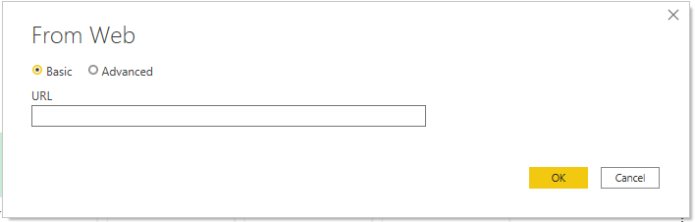

**Paste the link** [**https://en.wikipedia.org/wiki/Rahul_Dravid**](https://en.wikipedia.org/wiki/Rahul_Dravid) **in the URL**

**↓**

**Ok**

**↓**

**Select one table**

**↓**

**Load/Transform**

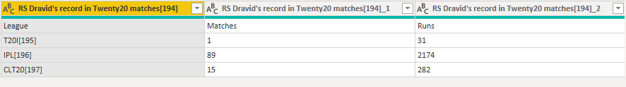

b) Create an xml file by yourself and read data from XML file into power bi

**After XML file creation**

**Power BI Desktop**

**↓**

**Home**

**↓**

**Get Data**

**↓**

**Excel(should read from the path)**

2.Transformations in Query Window

a.Emp.txt file has below data:

eno,ename,sal

1,haria,$5000

2,sasi,$6000

Remove $ from sal and show in Table visualization

**Transform**

**↓**

**Replace Values**

**↓**

**Value to find : $**

**Replace with :**

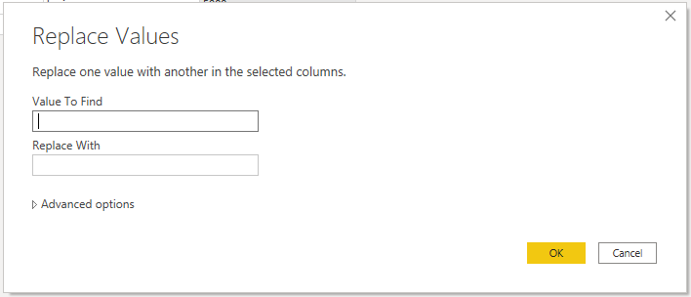

**↓**

**Ok**

b. Department.txt has below data

dno,dname,loc

10,maths,hyd

20,science,che

Departmenthistory.txt has below data

dno,dname,loc

30,History,mumbai

40,Commerce,Delhi

Read data from above files and using append queries combine data from both and show in Table visualization

**Get Data**

**↓**

**Text/Csv**

**↓**

**Append queries**

**↓**

**Two Tables**

**↓**

**Table to Append: Departmenthistory**

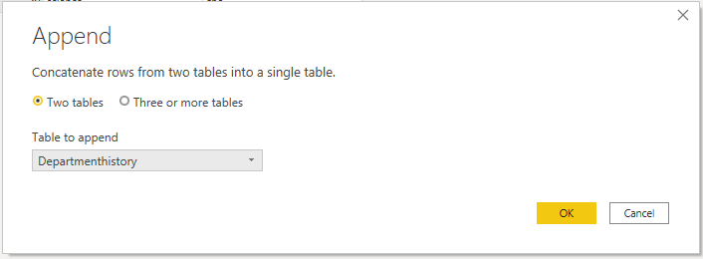

c. Read data from deparment.txt and remove loc colum in query and remove other columns other than loc column

**By selecting loc column**

**↓**

**Remove columns**

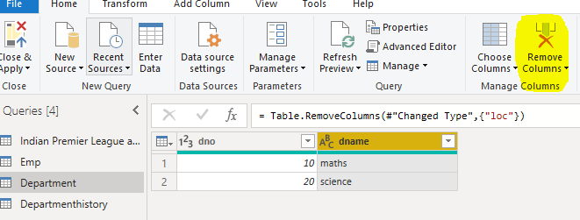

**By selecting loc column**

**↓**

**Remove other columns**

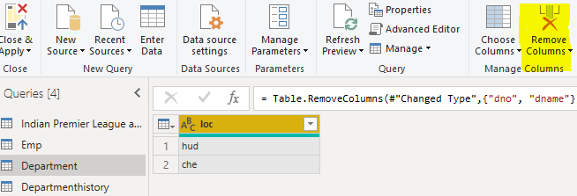

d. create table manually in query window with following data

colorid,colorname

1,Red

2,Blue

3,Green

**Home**

**↓**

**Enter Data**

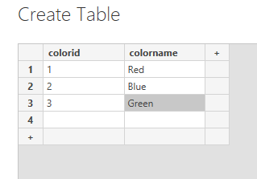

e. Reorder columns: colorname should come first followed by colorid

**We can reorder the columns by clicking move(left/right)**

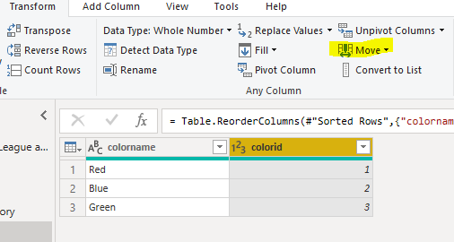

f. what is the purpose of choose columns and go to column in query window

**Choose columns – We can select some important columns based on our needs/requirements.**

**Go to column – If anything to perform/change in a particular column then we can go to that column using go to column.**

g. what is difference between use first row as headers and headers as first row

**First row as headers – By clicking first row as header, we can change the first row as header of the data.**

**Headers as first row – By clicking headers as first row, we can change the header as first row of the data.**

h. In querywindow for following data sort information first based on dno desc and with in each dno sal asc

emp.txt

dno,eno,sal

10,1,1000

10,2,2000

20,3,3000

20,4,4000

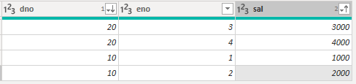

i.Pivot table and unpivot table

Unpivot below file data related to maths,physics and then pivot it back:

studentmarks

sname,maths,phyics

Hari,100,100

Kirshna,50,60

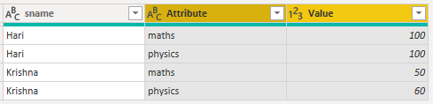

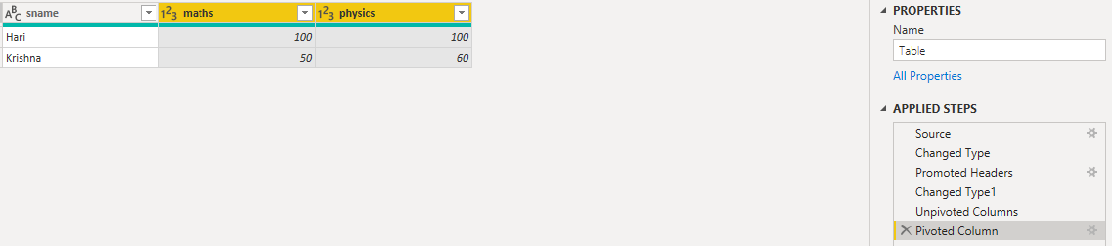

j. toprows, bottom rows ,range of rows, duplicates

emp.txt

dno,eno,sal

10,1,1000

10,2,2000

20,3,3000

20,4,3000

Show

Top 2 rows

Bottom 1 row

eno between 2 and 3

duplicate sal people

Top Two Rows:

**Keep rows**

**↓**

**Keep top rows**

**↓**

**Number of rows:2**

**↓**

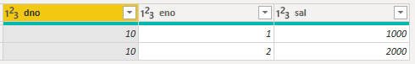

Bottom 1 row:

**Keep rows**

**↓**

**Keep bottom rows**

**↓**

**Number of rows:1**

**↓**



eno between 2 and 3:

**Keep rows**

**↓**

**Keep range of rows**

**↓**

**First row:2**

**Number of rows:2**

**↓**

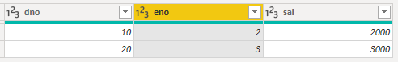

duplicate sal people:

**Keep rows**

**↓**

**Keep Duplicates**

**↓**

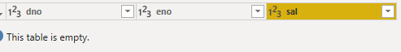

k. Mergequeries as new by Joining dept.txt and emp.txt on dno

**Merge queries**

**↓**

**Merge queries as new**

**↓**

**Join kind: Full outer**

**↓**

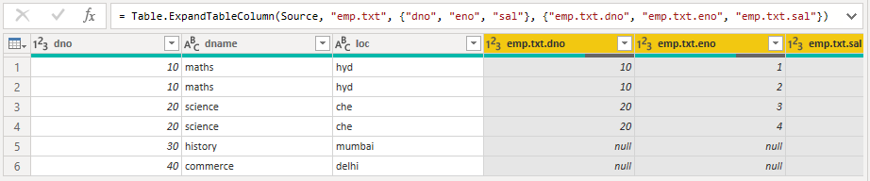

l. Split column

emp.txt file has below data:

eno,ename,sal

1,hari;krishna,$5000

2,sasi;kumar,$6000

Split ename into fname and lname fields.

**Split Columns**

**↓**

**Split by Delimiter**

**↓**

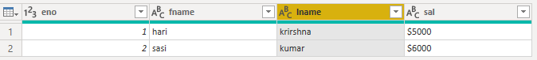

m.duplicate emp query, reference emp query and delete duplicated emp query

**Query**

**↓**

**Manage**

**↓**

**Duplicates**

**Query**

**↓**

**Manage**

**↓**

**Reference**

**Query**

**↓**

**Manage**

**↓**

**Delete**

n. queries to seperate groups

emp query put in seperate group and dept query in seperate group

**right click: move to group**

**↓**

**New group**

**↓**

**Emp data in separate group**

**↓**

**Dept data in separate group**

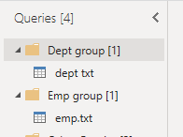

o. ungroup emp query

**right click on emp query**

**↓**

**ungroup**

**↓**

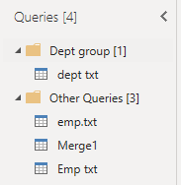

p. count rows in emp.txt file

**Transform**

**↓**

**Count rows**

**↓**

4

q. transpose category column of below file and then use firt row as headers to make category names as column names.

category.txt

categoryname,sales

c1,1000

c2,2000

c3,3000

**Transform**

**↓**

**transpose**

**↓**



r. sort emp query on desc order of sal

**Sort: Descending(Sal)**

